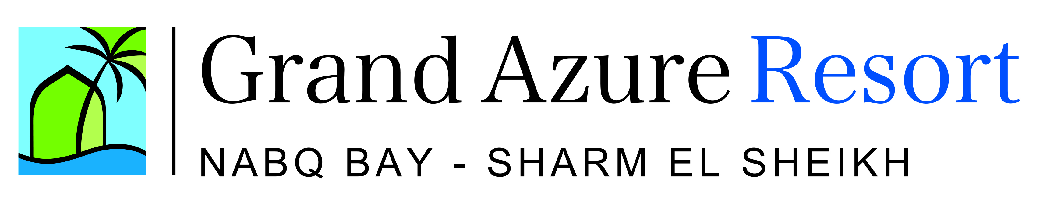

General information

- Address : Nabq bay – Sharm Elsheikh – South Sinai - Egypt
- Category : 5 stars
- Phone : +2 - 069 – 3710 130 / 149
- Fax : +2 – 069 – 3710 140
- E-Mail : info@grandazure-egypt.com
- Web site :
- Date of inauguration : July 2000
- Languages : Multilingual staff at the reception desk and animation team
- Type of catering :All Inclusive
- Location :Located directly on the beautiful, coral beach of Nabq bay
      - 9 km to Sharm El Sheikh international airport
      - 18 km to the shopping center of Na'ama bay
      - 25 km to Sharm El Sheikh old market
- Hotel features :
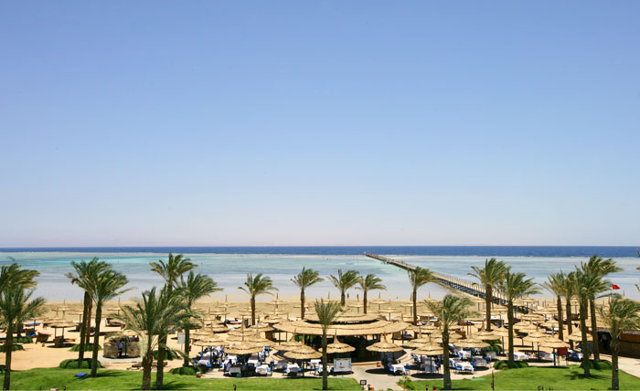
- Territory of the hotel: 200,000 sqm
- Length of Beach : 350 meter
- Jetty : 800 meter

Rooms

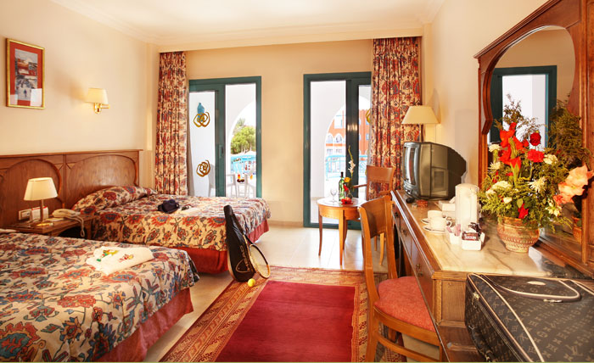
- Number of resort rooms : 814 rooms (23 buildings)
  - Superior rooms 380 rooms (42 sqm)
Bath, WC, bidet, hairdryer, air condition, direct dialing phone, LCD sat-TV, mini fridge, kettle, telephone in toilet, safe, balcony / terrace
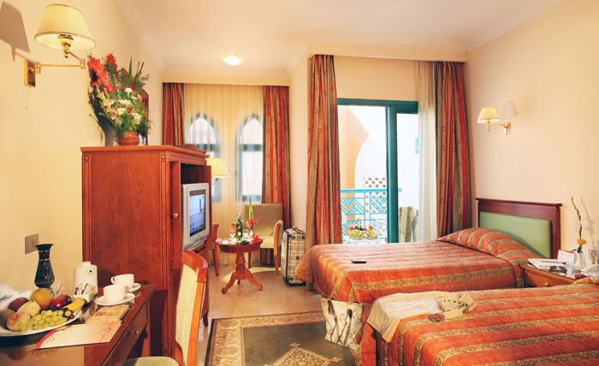
- Standard rooms 175 rooms (28 sqm)
Bath, WC, bidet, hairdryer, air condition, direct dialing phone, LCD sat-TV, mini fridge, kettle, telephone in toilet, safe, balcony / terrace

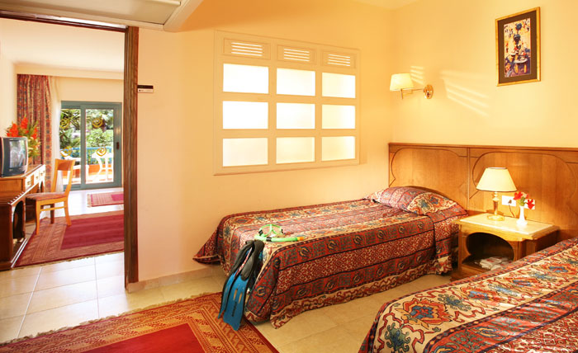
- Family room 73 rooms (60 sqm)
Bath, WC, bidet, hairdryer, air condition, direct dialing phone, LCD sat-TV, mini fridge, kettle, telephone in toilet, safe, balcony / terrace, bedroom + small additional room with 2 beds.
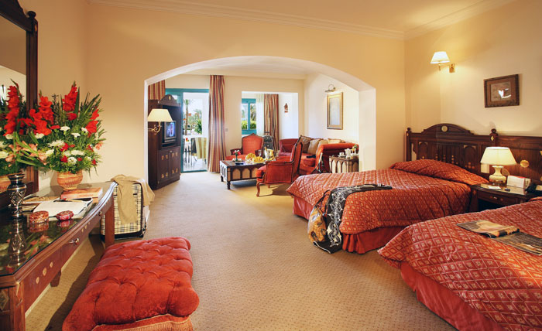
- Junior Suite 174 suites (60 sqm)
Bath with separation shower unit, living room with no separation, WC, bidet, hairdryer, air condition, direct dialing phone, LCD sat-TV, mini fridge, kettle, telephone in toilet, safe, balcony / terrace.
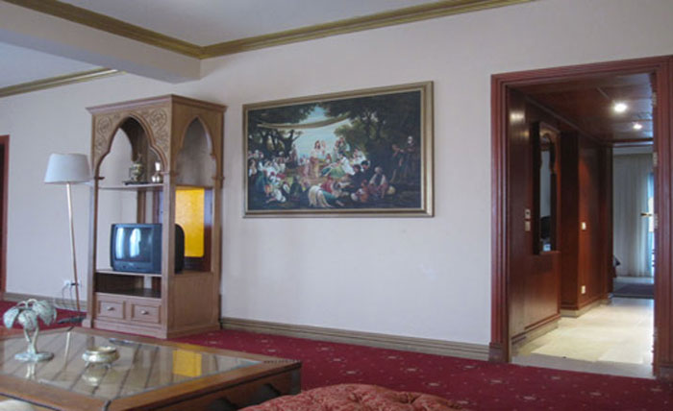
- Royal Suite 12 suites (100 sqm)
King Bed, bath with separation shower unit, living room with no separation, WC, bidet, hairdryer, air condition, direct dialing phone, LCD sat-TV, mini fridge, kettle, telephone in toilet, safe, balcony / terrace.
Sports, Entertainment and other facilities

- Daily soft animation program during the day, evening entertainment with traditional folkloric and international shows
- Animation with aerobic, gymnastic, dance lessons, pool and beach games
- Tennis court with extra charge (100 L.E. for 1 hour)
- Table soccer, dart, boccia, billiard tables, games land, table tennis, beach volleyball, Aqua park
- Water sports not included (Extra charge)
- Limousine service located in the lobby area (Extra charge)
- 3 outdoor pools with fresh water (Waterfalls 7500 sqm, – Dolphin pool 1200 sqm – Fountain pool 800 sqm – children’s’ pool 50 sqm).
- 1 small heated pool during the winter time
- 6 waterslides for all ages
- Parasols, sun loungers, mattresses and towels free of charge at pools and beach area
- Kids club 4-12 years, parental supervision is required (Ice cream, kids’ lunch, games land and multilingual speaking animation staff).
- Spa centre with free gym, sauna, steam and Jacuzzi as well as other facilities which are not included (massage, beauty treatments and Turkish bath, extra charge) (children under 16 years of age are not permitted to use the Spa facilities)
- Wifi internet connection free of charge in the lobby area only
- Internet café (Extra charge)
- Birthday, anniversary, honeymoon and repeated guests packages during the stay
- Shuttle bus to Na'ama Bay free of charge several times during the day
- ATM machine at hotel lobby area and CIB bank located on the remise of the hotel
- Main restaurant (serving breakfast, late breakfast, lunch, dinner and late light dinner)
- 4 A la carte restaurants (Chinese “Shanghai”, Italian “Bella Vista”, Mediterranean “Arabian Night”, Fish “Fisherman’s Catch”, for dinner time only) free of charge with reservation through the Guest Relation
- Medical service available in hotel during the clinic working hours, 24 hours Emergency (extra charge).
- 500 m to next chemistry and 25 km to next hospital
- Around the hotel property 7 bars serving guests local non alcoholic and alcoholic drinks during the bar opening times
- Pool snacks & Beach snacks available (time restrictions apply)
- Tirana restaurant – light lunch (pizza, pasta, salads)
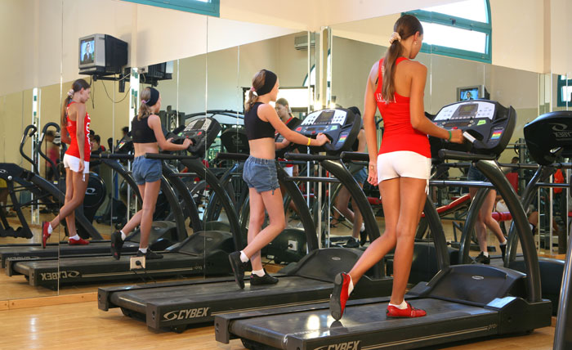
- Room cleaning with change of bed linen and towels on daily basis.

