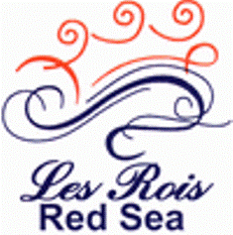**Info Sheet**

**Инфраструктура**

* **2 swimming pools (sweet water)**
* **Sun-beds and umbrellas**
* **Health Club, fully equipped with a sauna, gym, jacuzzi, massage  
  and steam room**
* **Billiard and satellite TV corner**
* **Beach (300 m from Hotel)**
* **Shopping arcade**
* **Parking area**

Рестораны

* Selection of outlets offering fine local and international cuisine
* **Main restaurant serving buffet breakfast and dinner with theme nights up to 500 seats**
* BBQ at pool terrace
* Roof top pool & bar
* Lobby bar
* 2 Discotheques

Recreation:

* 2 out door pools (sweet water)
* Fully equipped fitness center, health club, sauna, Jacuzzis and steam room